Lab 2: Build Virtual Network with Web & Data Subnets; Attach NSG; Validate Rules
Submitted by: Amrish Kumar
Assignment: Week 2 - Azure Networking Fundamentals Lab

Objective
The goal of this lab is to design and configure a Virtual Network (VNet) in Azure with separate subnets for web and data tiers. Network Security Groups (NSGs) will be attached to control traffic flow between subnets and external access. Validation will be performed to ensure the configured rules function as expected.

Step 1: Create a Virtual Network (VNet)
1. Open the Azure Portal (https://portal.azure.com).
2. Search for 'Virtual networks' and click on 'Create'.
3. Under 'Basics':
- Subscription: Select your active subscription.
- Resource Group: Choose an existing RG or create a new one (e.g., 'rg-week2-lab').
- Name: Enter 'vnet-week2-lab'.
- Region: Select 'East US' or your preferred region.
4. Click 'Next: IP Addresses'.
5. Configure the address space (e.g., 10.0.0.0/16).
6. Add two subnets:
- Web Subnet: 10.0.1.0/24
- Data Subnet: 10.0.2.0/24
7. Click 'Review + Create' and then 'Create'.

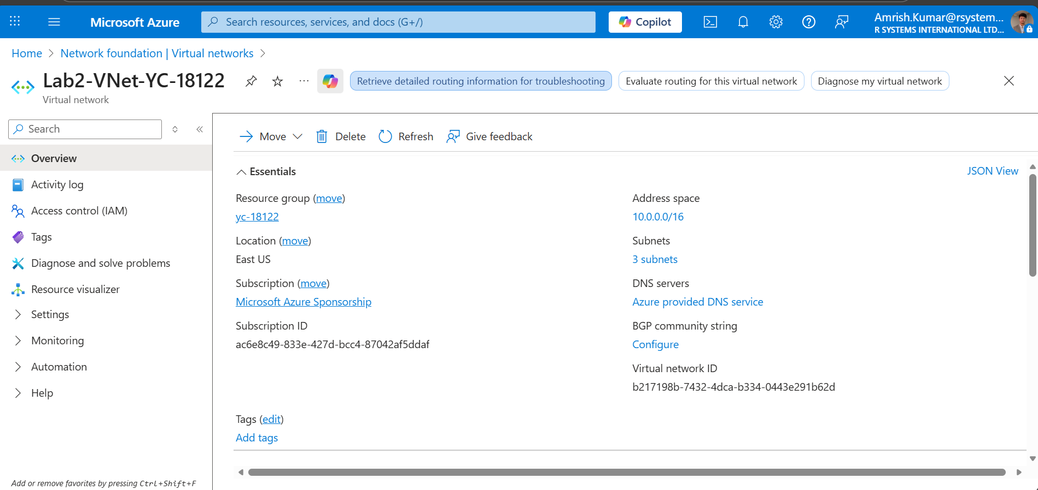

Step 2: Add Data Subnet
If the Data subnet was not created in the initial step, add it separately using the Azure Portal or CLI.
**Portal Steps:**
1. Open your Virtual Network.
2. Go to 'Subnets' and click 'Add Subnet'.
3. Enter the following:
- Name: data-subnet
- Address range: 10.1.1.0/24
4. Save the configuration.
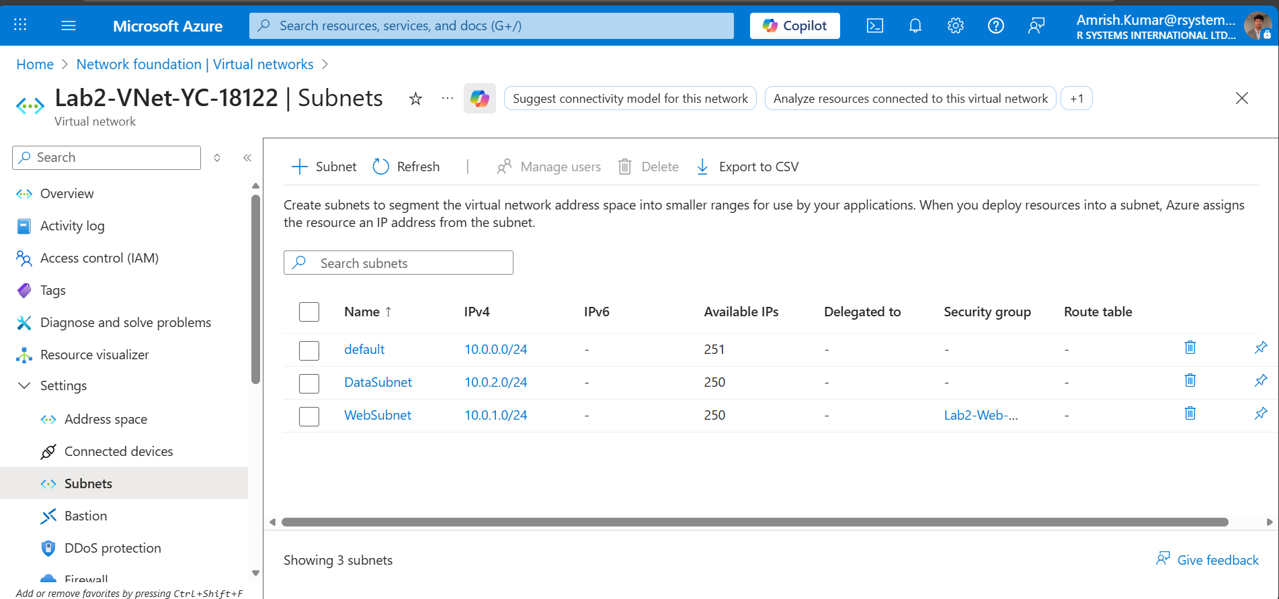

Step 3: Create and Attach Network Security Group (NSG)
Network Security Groups control inbound and outbound traffic for Azure resources.
**Steps to Create NSG:**
1. In the Azure Portal, search for 'Network Security Groups' and click 'Create'.
2. Choose your resource group.
3. Name the NSG (e.g., nsg-web-tier).
4. Click 'Review + Create' → 'Create'.
**Attach NSG to Web Subnet:**
1. Open the NSG.
2. Navigate to 'Subnets' and click 'Associate'.
3. Select your Virtual Network (vnet-week2-lab) and Web Subnet.
4. Click 'OK'.
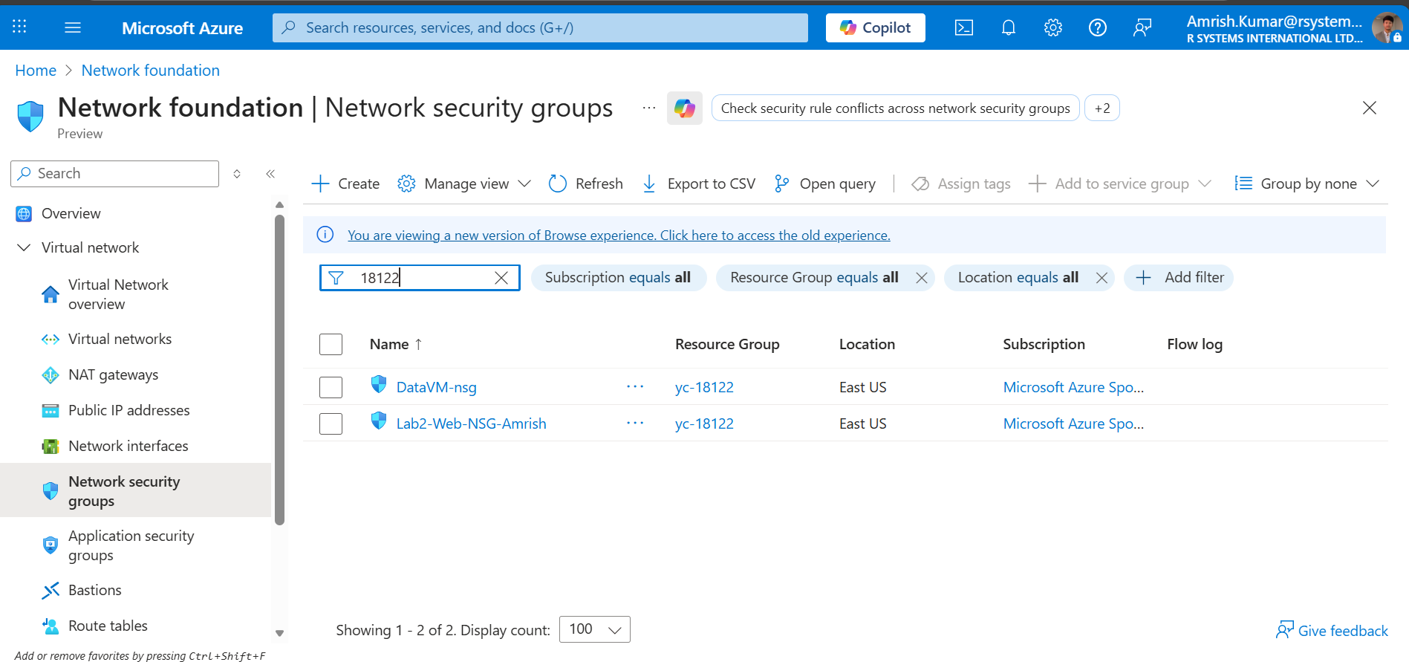

Step 4: Add Inbound and Outbound Security Rules
Security rules define the traffic allowed or denied to network interfaces, subnets, or VMs.
**Common Rules:**
- Allow inbound HTTP (Port 80) and SSH (Port 22) for Web Subnet.
- Deny all inbound traffic from external sources to Data Subnet.

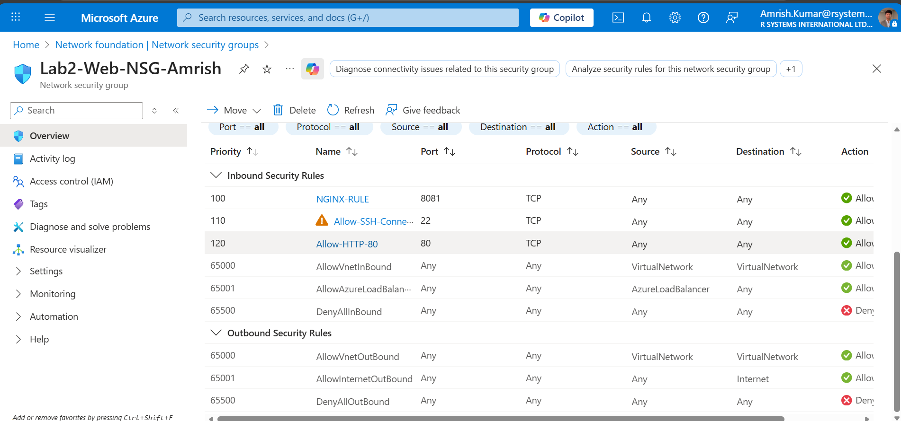

Step 5: Validate Network Rules
To confirm that the NSG rules are functioning correctly:
1. Deploy two VMs – one in the Web Subnet and one in the Data Subnet.
2. Try accessing the Web VM using SSH or HTTP.
3. Attempt to access the Data VM from outside — it should be blocked.
4. Check 'Effective Security Rules' in the NSG overview for verification.

Conclusion
In this lab, we successfully built a Virtual Network with dedicated subnets for Web and Data layers, attached and configured Network Security Groups, and validated the security rules. This setup ensures network segmentation and controlled communication between application tiers, which is essential in secure cloud architecture design.

